/\*Assignments based on Interfaces and Abstract Classes\*/

Program1-Interface

import java.io.\*;

interface In1

{

final int a = 10;

void display();

}

public class TestClass implements In1

{

public void display()

{

System.out.println("Geek");

}

public static void main (String[] args)

{

TestClass t = new TestClass();

t.display();

System.out.println(a);

}

}

Output-

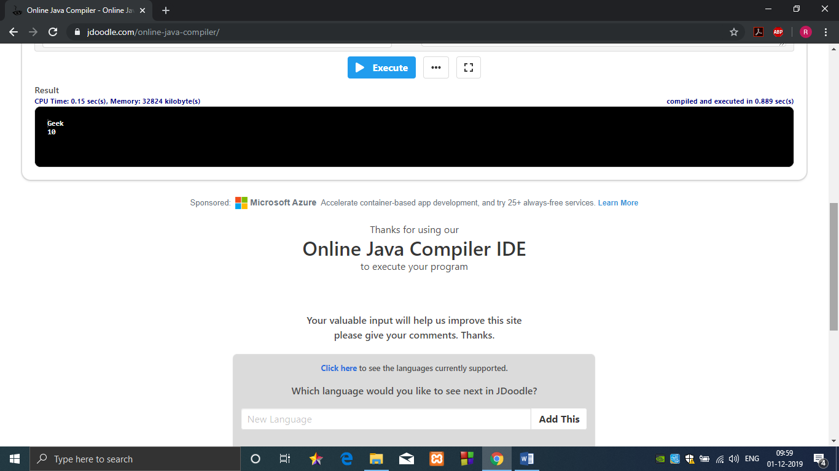

Program2-Abstract Class

abstract class Base

{

Base()

{

System.out.println("Base Constructor Called");

}

abstract void fun();

}

class Derived extends Base {

Derived() { System.out.println("Derived Constructor Called"); }

void fun() { System.out.println("Derived fun() called"); }

}

public class Main {

public static void main(String args[]) {

Derived d = new Derived();

}

}

Output-

